To copy jobs from one jenkins to another just copy them from

C:\Jenkins\jobs

To C:\Jenkins\jobs

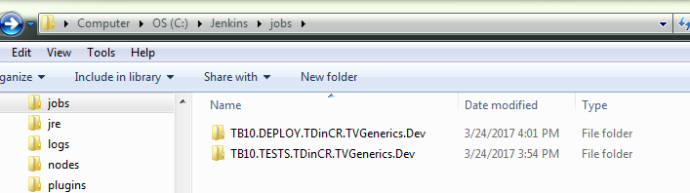

Run some job on Jenkins and check on otput for errors to fix:

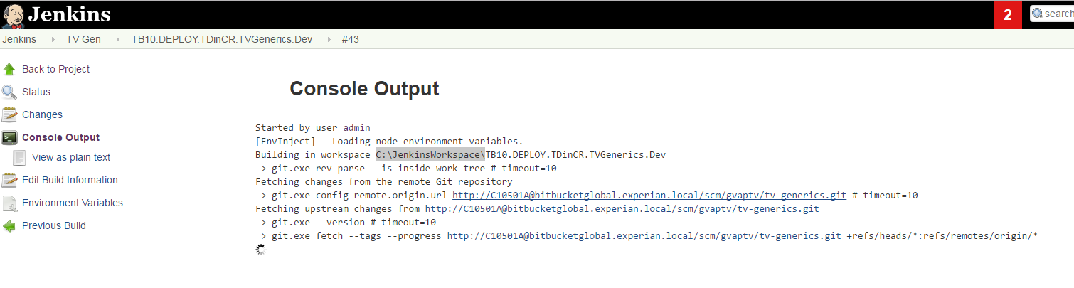

If the job runs OK you are done.

To export Jobs justs copy Jobs folder from

C:\Program Files (x86)\Jenkins\Jobs

To export views just copy <listView>…</listView> contents from

C:\Program Files (x86)\Jenkins\config.xml to another and then go to Jenkins-> reload from disk